A Material Flow Cost Accounting Approach to Improvement Assessment in LCA
Tobias Viere¹, Andreas Möller² and Martina Prox³
¹IFU Hamburg GmbH, Research Fellow of the Centre for Sustainability Management (CSM), Leuphana University of Lüneburg
²Institute for Environmental Communication, Leuphana University of Lüneburg
³IFU Hamburg GmbH, Research Fellow of the Centre for Sustainability Management (CSM), Leuphana University of Lüneburg
Corresponding Author: m.prox@ifu.com

Abstract
This paper examines the usefulness of material flow cost accounting (MFCA) for life cycle assessment (LCA), particularly with regard to improvement assessment. It explains the basic MFCA methodology and its consequences for allocation and by-product handling in LCA. The paper argues that the integration of material flow cost accounting methods into LCA, and environmental life cycle costing respectively, provides additional benefit for business decision making. In addition, the benefit of applying MFCA to LCA results is exemplified for the life cycle of coffee.
Keywords: Material Flow Cost Accounting, Efficiency, Improvement Assessment, Sustainable, Coffee Life Cycle.

Introduction
Companies measure, collect, aggregate, analyze and report information to provide relevant information for internal decision making and to satisfy the information demand of authorities, shareholders, creditors, and other stakeholders. In principle, life cycle assessment (LCA) can serve both, external and internal purposes. A survey on LCA in business (Frankl & Rubik 1999a) has shown that the majority of drivers and applications of LCA in companies are related to internal decision making rather than external information management. Their study, covering Germany, Italy, Sweden and Switzerland, revealed that LCA is one among several tools that companies apply to improve the environmental performance of their products. Consequently, bottleneck identification, comparison of existing products with planned alternatives and product benchmarks were among the most important applications of LCA named by the surveyed companies (Frankl & Rubik 1999a; a condensed version of the survey can be found in Frankl & Rubik 1999b).
Managers are likely to apply LCA as a tool for internal decision making if the information received helps to identify and assess options for improvement which can be directly influenced by their action. The SETAC-triangle (Figure 1) illustrates the results of several important LCA workshops in the early 1990s and highlights the importance of improvement assessment in LCA. In later years during the standardization process resulting in ISO 14040ff., improvement assessment has not been considered as integral part of LCA anymore, but as one possible application linked to the interpretation step of LCA (Klöpffer 1997).
At first glance, material flow cost accounting (MFCA) has nothing in common with LCA. While the latter focuses on products and the whole life cycle, MFCA has been developed to visualize the cost of inefficiencies in production, in particular the costs of wasted materials. On second sight, though, it becomes obvious that LCA and MFCA share some common objectives if applied in a business context. According to Frankl & Rubik (1999a), for instance, companies’ decision to apply LCA is not purely driven by environmental awareness, but also by cost saving opportunities and cost avoidance in the future.
This paper explores the usefulness of applying MFCA methodology in a LCA context in order to increase the relevance of LCA results for companies’ internal decision making.

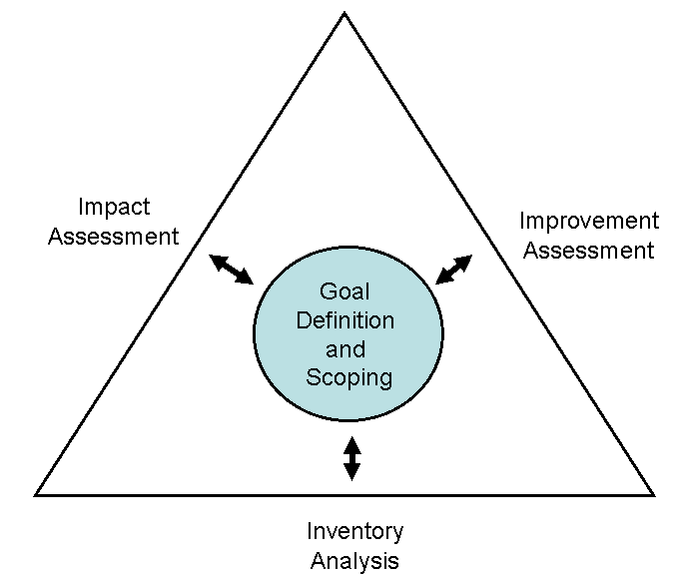
Figure 1: SETAC-triangle (Source: Klöpffer 1997, 224)

Material Flow Cost Accounting
MFCA combines physical and financial information concerning a company’s performance to reduce wastage and thereby improve resource efficiency and environmental performance (cp. e.g. Jasch 2009, METI 2007, Strobel & Redmann 2002. Wagner & Enzler, 2006). It derives from more general concepts such as material flow analysis (cp. e.g. Brunner & Rechberger, 2003) and environmental accounting (cp. e.g. Schaltegger & Burritt, 2000).
The quantification and visualization of material losses is the overall objective of MFCA and leads to a better consideration of waste-induced inefficiencies in business decision making. The basic approach is illustrated in Figure 2. The crucial difference to conventional cost accounting is that material and other costs of a process are not only allocated to products, but also to product-related waste based on physical causalities. MFCA implies a linear relationship of inputs and outputs: a reduction of product-related waste leads to a reduction of input flows. For instance, a waste reduction of 10kg in the upper Sankey diagram of Figure 2 would reduce the total output (100kg) by 10% and thus all inputs by 10%, too. Accordingly, costs would be cut. The information that waste-induced costs total to 45 EUR (cp. lower diagram in Figure 2), or 1.5 EUR/kg waste respectively, supports managers and other decision makers in taking action to reduce such inefficiencies.
Although the main motivation to use MFCA is cost reduction, it leads to ecological implications as well. The left Sankey diagram in Figure 3 shows an extension of the process depicted in Figure 2. It includes further inputs, process water and diesel fuel, which are not intended to become part of the final product, and some of the related outputs, namely waste water and carbon dioxide (for the purpose of simplification other emissions than carbon dioxide deriving from diesel fuel combustion have been excluded). The MFCA reasoning implies that less product-intended waste will result in reduced inputs including less process water and diesel fuel which finally leads to a reduction of waste water and carbon dioxide. This is illustrated in the right Sankey diagram of Figure 3: All physical flows labeled ‘wastage’ could be eliminated by cutting the product-related waste flow to zero. In this regard it is important to distinguish waste flows which are product-intended, i.e. they could have become part of the product in a more efficient production system, and waste flows that are not feasible to become physical part of the final products. A reduction of the latter, e.g. wastewater from cleaning within the process, does not result in raw material or other product-related savings.

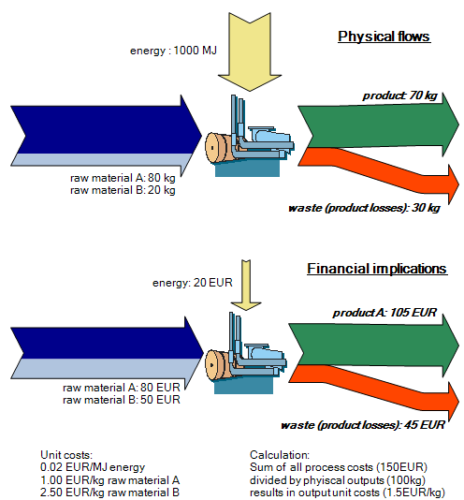
Figure 2: Basic MFCA approach (Source: own picture)

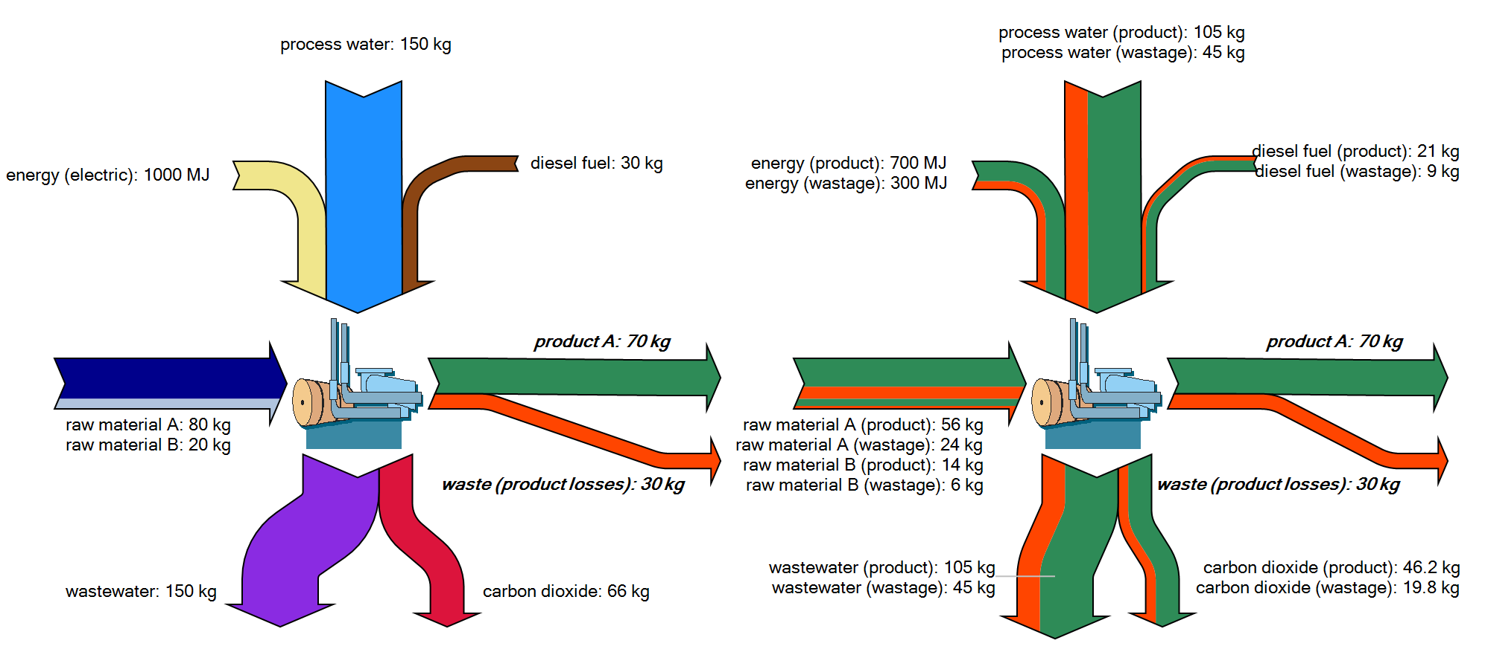
Figure 3: Ecological implications of MFCA (Source: own picture)

By assuming that product and product-intended waste flows feature a linear proportionality to all other process flows, MFCA is simplifying the reality of production processes immensely. Therefore, decision makers are recommended to treat the financial and ecological saving potentials derived from MFCA as an approximation rather than a precise calculation. Nevertheless, such results support the identification and implementation of improvement processes which integrate ecological and economic aspects, increase eco-efficiency and are relevant even for conventional management decision making. In so doing, MFCA meets the integration challenges of corporate sustainability management (cp. Schaltegger et al., 2002 for a discussion on the integration challenges of sustainability management).
The capability of MFCA becomes even more evident if it is used to analyze not just one process, but a whole system of processes, e.g. a production plant, a supply chain or even a whole life cycle model. Figure 4 depicts a simplified life cycle model. In many cases, an efficiency increase in a downstream process causes huge financial savings and environmental improvements upstream, a fact that is well known and has for instance inspired concepts like MIPS (Material Input Per Service unit, cp. Ritthoff et al., 2002).

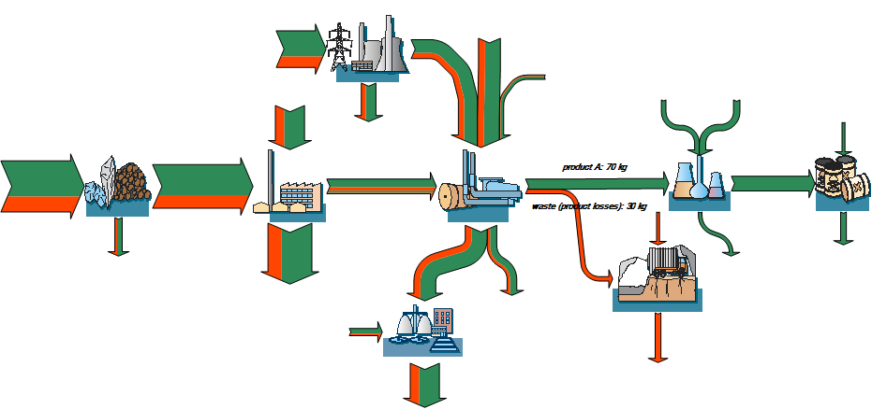
Figure 4: Wastage- and product-related flows in a life cycle model (Source: own picture)

Implications for Life Cycle Assessment and Exemplification
In a graphical manner, the Sankey diagram in Figure 4 already suggests a link of MFCA to life cycle assessment (LCA, for an introduction and guidance on LCA cp. e.g. Baumann & Tillmann, 2004) and environmental life cycle costing (eLCC, cp. e.g. Hunkeler et al., 2008). From a resource efficiency point of view, life cycle inventories do usually not depict an ideal state of a product under examination. Instead, the status quo including waste flows and other potential inefficiencies is examined and analyzed. Assuming that the graphical life cycle model in Figure 4 is a single product system, an LCA/eLCC would trace all physical flows and related environmental impacts as well as costs to that single product and its benefit respectively. This includes the product-intended waste and its treatment. MFCA can contribute to LCA/eLCC based improvement assessments by quantifying and visualizing the contribution of such wastage to upstream and downstream processes, physical flows, environmental impacts and costs.
Basically, using MFCA in LCA/eLCC improvement assessment means to define product-intended waste as by-product. The system under examination thus becomes a multi-product system and requires allocation rules to distinguish the contribution of each product to the total result. MFCA uses physical properties (weight ratio, volume ratio etc.) for allocation purposes, which is in line with allocation in LCA according to ISO 14044. There is a crucial difference to ordinary allocation in LCA in terms of usage, though. In conventional LCA, allocation is used to subtract and exclude the flows and impacts related to a by-product from the system under examination. In an MFCA-based improvement assessment the allocation does not lead to exclusion, but to a breakdown of the overall results into product and wastage-related flows, impacts and costs within the examined system.
To support a MFCA-based improvement assessment, life cycle models need to clearly identify product-intended waste and separate it from other, non-product-intended waste. This implicates a new challenge for modeling and quantifying life cycles.
The benefit of using MFCA for LCA and eLCC is constituted by the improved consideration of inefficiencies within the system under examination and the consequent identification of options to reduce these inefficiencies in order to reduce environmental impacts and enhance economic performance. This can be exemplified by looking at LCA studies on coffee conducted by Diers et al. (1999) and Salomone (2003). The authors of both papers assessed the life cycle of coffee and mentioned several options for improvement. Besides coffee cultivation, coffee consumption and particularly the energy required to brew coffee plays an important role in both LCA studies. However, another aspect of coffee consumption is not getting much attention: On average, consumers pour away one cup of coffee per can of brewed coffee, which equals wastage of roughly 20% (ICO 2001). From a MFCA point of view the poured away coffee is of huge importance. If consumers brew exactly as much coffee as they like to drink, the inputs of coffee brewing such as coffee powder, water and electric energy would be immediately cut by 20%. Even more important, corresponding flows in upstream steps of the life cycle would be reduced, too, e.g. fertilizer and land use in cultivation or fuel consumption in overseas transportation. A MFCA-based improvement assessment in LCA would not only look at this inefficiency in the consumption stage, but also at inefficiencies at other life cycle stages, for instance the commonly occurring over fertilization in coffee cultivation, which leads to unnecessary environmental impacts and higher production costs for the whole coffee supply chain (cp. Viere et al., 2007 for a case study on using supply chain and life cycle information for a coffee exporter’s business decision making).

Conclusion
LCA and eLCC can benefit from integrating MFCA methodology as it reinforces improvement assessment and thereby increases the relevance of LCA/eLCC results for business decision making. The consequent consideration, quantification and visualization of wastage and inefficiencies support managers and other decision makers in tackling such problems. In an ideal situation diminishing inefficiencies in a product life cycle results in less environmental harm and greater financial benefits at the same time. However, even a highly efficient life cycle might still be a threat to sustainable development. The overall assessment of ecological effectiveness remains a vital task of LCA.
This paper has presented the usefulness of MFCA methodology for improvement assessment in LCA. In this respect, MFCA is a subordinated methodology to LCA. Möller & Prox (2008) took a different approach by placing MFCA at the starting point of all activities in the field of material flow analysis, LCA and related cost accounting approaches. They propose to start on a production improvement level using MFCA. Based on experiential learning their approach subsequently expands the analysis to value chains and finally full life cycle assessments. From a business perspective this might well be a useful “road map” to follow as it increases the complexity and scope of a company’s environmental improvement processes stepwise.
Eventually, it does not matter whether MFCA is a subordinate to LCA or vice versa as long as both tools and their combination provide useful information for decision makers to improve the environmental and financial performance of their company and their products’ life cycles.

References
Baumann, H & Tillmann AM (2004), The hitch hikers's guide to LCA : an orientation in life cycle assessment methodology and application, Studentlitteratur AB, Lund.
Brunner, PH & Rechberger, H (2003), Practical Handbook of Material Flow Analysis, CRC, Boca Raton, Florida.
Diers, A, Langowski, HC, Pannkoke, K & Hop, R (1999), Produkt-Ökobilanz vacuumver-packter Röstkaffee, Eco-Informa Press, Bayreuth.
Frankl, P & Rubik, F (1999a), LCA in Industry and Business - Adoption Patterns, Applications and Implications, Springer, Heidelberg.
Frankl, P & Rubik, F (1999b), “Life-cycle assessment (LCA) in business – an overview of drivers, applications, issues and future perspectives”, Global Nest: the International Journal, 1 (3), pp. 185-194.
Hunkeler, D, Lichtenvort, K & Rebitzer G (eds) (2008), Environmental Life Cycle Costing, CRC, Boca Raton, Florida.
ICO – International Coffee Organization (eds) (2001), Environmental issues relating to the coffee chain within a context of trade liberalization, through a life-cycle approach, ICO, London.
ISO 14040:2006 - Environmental management - Life cycle assessment - Principles and framework.
ISO 14044:2006 - Environmental management - life cycle assessment - requirements and guidelines.
Jasch, C (2009), Environmental and Material Flow Cost Accounting: Principles and Pro-cedures, Springer, Dordrecht.
Klöpffer, W (1997), “Life Cycle Assessment – From the Beginning to the Current State”, Environmental Science & Pollution Research 4 (4), pp. 223-228.
Kokubu, K, Campos, MKS, Furukawa, Y & Tachikawa, H (2009), “Material flow cost ac-counting with ISO 14051”, ISO Management Systems (January-February 2009), pp. 15-18.
METI -Japanese Ministry of Economy, Trade and Industry (2007), Guide for Material Flow Cost Accounting, METI, Tokyo.
Möller, A & Prox, M (2008), “From Material Flow Cost Accounting to MFA and LCA”, Proceedings of the Eighth International Conference on EcoBalance 2008 - The challenge of creating social and technological innovation through system-thinking, Dec. 10-12, To-kyo.
Ritthoff, M, Rott, H & Liedtke, C (2002), Calculating MIPS – Resource productivity of products and services, Wuppertal Institute, Wuppertal.
Salomone, R (2003), “Life cycle assessment applied to coffee production: investigating environmental impacts to aid decision making for improvements at company level”, Food, Agriculture & Environment, vol. 1, no. 2, pp. 295-300.
Schaltegger, S & Burritt, RL (2000), Contemporary Environmental Accounting – Issues, Concepts and Practice, Greenleaf, Sheffield.
Schaltegger, S, Herzig, C; Kleiber, O & Müller, J (2002), Sustainability management in business enterprises : concepts and instruments for sustainable organization development, Federal Ministry for the Environment, Nature Conservation and Nuclear Safety, Bonn.
Strobel, M & Redmann, C (2002), “Flow cost accounting, an accounting approach based on the actual flows of materials”, in Bennett, M, Bouma, JJ, Wolters, T (eds), Environ-mental management accounting: informational and institutional developments, Springer, Dordrecht, pp. 67-82.
Viere, T, Schaltegger, S & von Enden, J (2007), “Using Supply Chain Information for EMA – the Case of a Vietnamese Coffee Exporter”, Issues in Social and Environmental Accounting, Vol. 1, Issue 2.
Wagner, B & Enzler, S (eds.) (2006), Material flow management: improving cost efficiency and environmental performance, Physica, Heidelberg.

